**Q.7. Create supertype person_typ with attributes id, name, phone_no and member function show that returns id and name of the person. Create table person of person_typ and insert records into it and display id and name of person using show function. Create subtype student_type of spertype person_typ  with attributes dept_id and major. It has member function show that overrides member function of person_typ and returns the major of student. Create table student of student_type and insert record into it and display major of the student using show function.**

**SQL Query:**

CREATE OR REPLACE TYPE person_typ AS OBJECT (

id INT,

name VARCHAR(50),

phone_no VARCHAR(15),

MEMBER FUNCTION show RETURN VARCHAR2

);

CREATE TABLE person OF person_typ;

-- Insert records into the person table

INSERT INTO person VALUES (person_typ(1, 'John Doe', '555-123-4567'));

INSERT INTO person VALUES (person_typ(2, 'Jane Smith', '555-987-6543'));

-- Add more records as needed

-- Define the member function 'show' for 'person_typ'

CREATE OR REPLACE TYPE BODY person_typ AS

MEMBER FUNCTION show RETURN VARCHAR2 IS

BEGIN

RETURN TO_CHAR(self.id) || ' - ' || self.name;

END;

END;

CREATE OR REPLACE TYPE student AS OBJECT (

person_data person_typ,

dept_id INT,

major VARCHAR(50),

MEMBER FUNCTION show RETURN VARCHAR2

);

CREATE TABLE studentinfo OF student;

-- Insert records into the student table

INSERT INTO studentinfo VALUES (student(person_typ(3, 'Alice Johnson', '555-111-2222'), 101, 'Computer Science'));

INSERT INTO studentinfo VALUES (student(person_typ(4, 'Bob Williams', '555-333-4444'), 102, 'Engineering'));

-- Add more records as needed

-- Define the member function 'show' for 'student'

CREATE OR REPLACE TYPE BODY student AS

MEMBER FUNCTION show RETURN VARCHAR2 IS

BEGIN

RETURN self.major;

END;

END;

-- Display id and name of persons using 'show' function

SELECT p.person_data.id, p.person_data.show() AS person_name FROM studentinfo p;

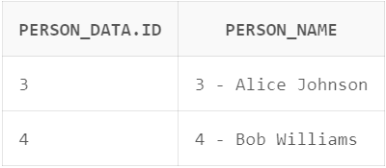

-- Display major of students using 'show' function

SELECT s.person_data.id, s.show() AS student_major FROM studentinfo s;

